5th Grade Scient ific
Story Lessons

By Jack Duffin, Jason Franks,
Kyle Jones, and Joe Malliaras

History of The Elements
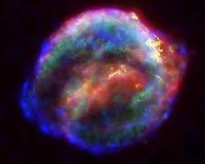
Ever since the universe came into existence, there has been elements. Hydrogen and helium are the most commonly found in the early existence of planets and in stars. Slowly more and more elements are discovered by different types of people. The first person to discover an element was a German physician named Hennig Brand. He discovered phosphorus in 1669. As the years progressed people have discovered more and more elements. The next element to be discovered was cobalt in 1735 by Georg Brandt. After this there was a new element discovered at least once every ten years, sometimes more. From 1807 to 1808, there were 7 new element found, and seven of them were by one English Chemist, Sir Humphry Davy. He discovered potassium, sodium, barium, strontium, calcium, and magnesium. Elements continued to be discovered by people from all around the world. Another chemist found multiple elements. He was a Swedish chemist named Carl Gustav Mosander. He discovered 2 in 1839 and 2 in 1843. They were cerium, lanthanum, terbium, erbium. New element were discovered until 1954, when the last element was discovered, by a researcher at Cal Berkeley, named Albert Ghiorso.
Some of the elements came into existence by dying stars, which is shown to the left.
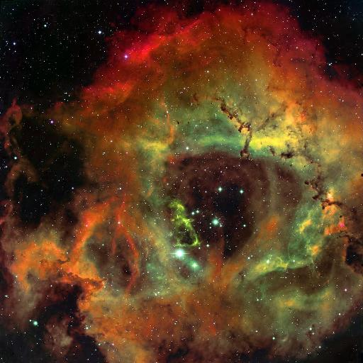

Almost all of the color and the dust in the picture is helium and hydrogen. Isn’t that crazy that the galaxy was only made up of 2 elements after the big bang with over 100 elements in existence!

Matter and Elements
The definition of matter is a physical substance and a physical substance is made up of elements or is an element. Think of a piece of granite. Would you think of the elements within it or would you think it is just a rock?

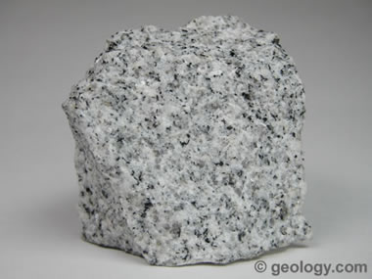

This, infact, is made up of iron, magnesium, titanium, calcium and sodium, and enrich the melt in potassium and silicon. These elements make the rock what it is, hard, solid, and beautiful.
Everything has elements in it. For example, take the pencil that is on your desk or the piece of paper.
The elements in your pencil are carbon, oxygen, hydrogen, nitrogen, and zinc oxide.
The elements in your paper are mainly carbon, hydrogen and oxygen.
Atoms in Chemical Reactions
Atoms are elements and the size of an atom determines what element it is. Each atom contains protons, neutrons, and electrons. Element number two is helium, so it contains 2 protons, 2 electrons, and 2 neutrons. For example, hydrogen is the smallest atom because it only has one proton.

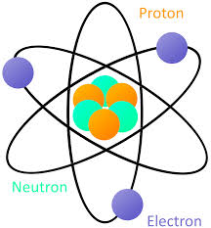

As you can see, this is a lithium atom because it has 3 protons and 3 electrons
When elements react to each other they form products, and only the atoms that are present can become part of the product. No atoms are destroyed or made. In a chemical reaction, reactants contact each other, bonds between atoms in the reactants are broken, and atoms rearrange and form new bonds to make the products.

Pure Elements and Combinational Elements
When you look at the periodic table you are looking at the pure elements because they are by themselves. A combinational element is a combination of two or more elements to create a new substance. An example is H2O which is water.

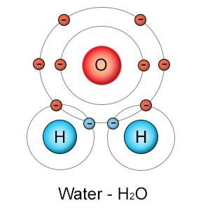

As you can see there is one oxygen atom and two hydrogen atoms creating water. This is the most common example of a combinational element.
Combinational elements are not on the Periodic Table, but they are made up from things off of the periodic table which only contain pure elements.

Chemical and Physical Properties
A chemical property is a material’s property after a chemical reaction has occurred. A physical property is the physical appearance of a material after it has occurred a change. A chemical change would be the separate two hydrogen atoms and the separate oxygen atom to create one water molecule. A physical change would be the gases turned into water.

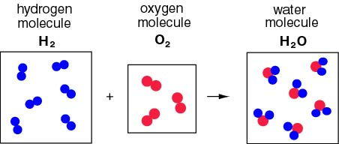

The image above shows the changes from separate atoms to one molecule.

Pop Quiz

- What two elements were found in space after star explosions?
- What is matter?
- What 3 things makes up an atom?
- What is a combinational element?
- What is a chemical property?

Answer sheet
- Hydrogen and helium.
- A physical substance.
- Protons, neutrons, electrons.
- A combination of two or more atoms to create a new substance
- A material’s property after a chemical reaction has occurred.

Properties of Matter
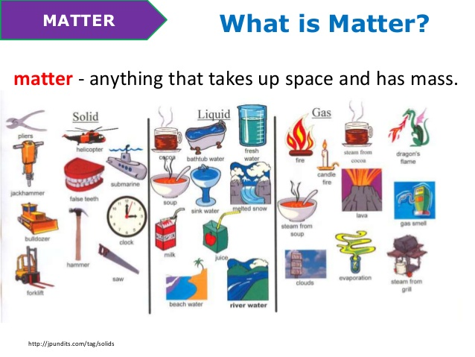
Matter is anything that takes up space and has mass. Look around the world, inside, outside, everywhere. Everything you see and even several things you do not see are considered matter. Your teacher is matter, your desk is matter, your drinking water is matter, even the air you cannot see or touch is matter!
There are three different types of matter: solids, liquids, and gases. Most items used by us humans are solids. Your house, a football, and your books are all examples of solids. If an item is a solid, it means the atoms in this solid are in a fixed position, hardly moving at all.
The second type of matter is the liquid form. The most common liquid is water, but there are a ton more out there! Some more examples of liquid are milk, snow, soup, and more. Liquids have atoms that are able to move slightly, making it so you can put your hand right through them.
The final type of matter is the interesting gas form. When you think of gas, the most common thing that comes to mind is car gas. However, this is not a gas, it is actually a liquid. Types of actual gasses include the air, steam, evaporation, and fire. Many gasses you cannot see, such as oxygen, which keeps us alive. In gases, atoms move around freely, giving them no physical feeling, and often making them invisible!

Organisms With Elements

As you have learned, an element is a substance composed of only one type of atom. Everything in the world is made of elements. There over one-hundred of them all together on one periodic table.
Every organism, or every living thing, is composed of elements. While there are other elements in organisms, there are six elements that are in every single one. These are Carbon, Hydrogen, Nitrogen, Oxygen, Phosphorous, and Sulfur.
Carbon is responsible for carbohydrates, proteins, nucleic acids, and lipids in organisms. It is one of the most versatile elements.
Hydrogen is another crucial element. It creates vital hydrogen bonds in organisms that are important.
Nitrogen contributes to over 70% of the Earth’s atmosphere. It is essential to all living organisms including organisms.
Oxygen is likely the most popular elements. It is present in Earth’s air and many elements and is what humans breathe to stay alive.
Phosphorous is never found alone. It is always in a mixture, and is used in fertilizers and used with organism growth.
Sulfur is the final essential element. Sulfur is what helps proteins in organisms do their jobs, which is necessary for organisms.

Properties of Salts

All salts are made up of a solid and chlorine. Also all salts are crystals and crystal like compounds like a table salt. Table salt is called Sodium Chloride and is a hard crystal substance. All salts are electrically neutral and all salts are an ionic compound. The structure of these compounds are cube shaped, like all other crystals.
Ionic compounds are hard and brittle because their ions are arranged into unit cells which form layers. As long as the layers stay aligned, the ionic compound is hard. But, if one layer is shifted, like charges will be next to one another. The repulsive forces between like ions causes the layers to break apart. Ionic compounds have higher melting and boiling points compared to other types of compounds (covalent compounds) because the ions in an ionic compound form strong bonds with a number of different ions due to their arrangement into crystalline structures.
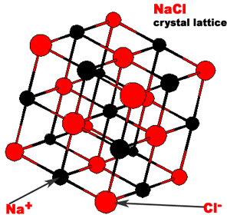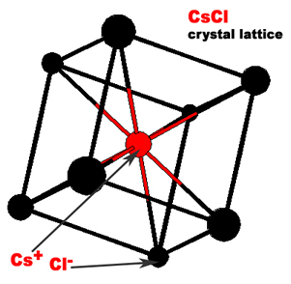

How to Read A Periodic Table
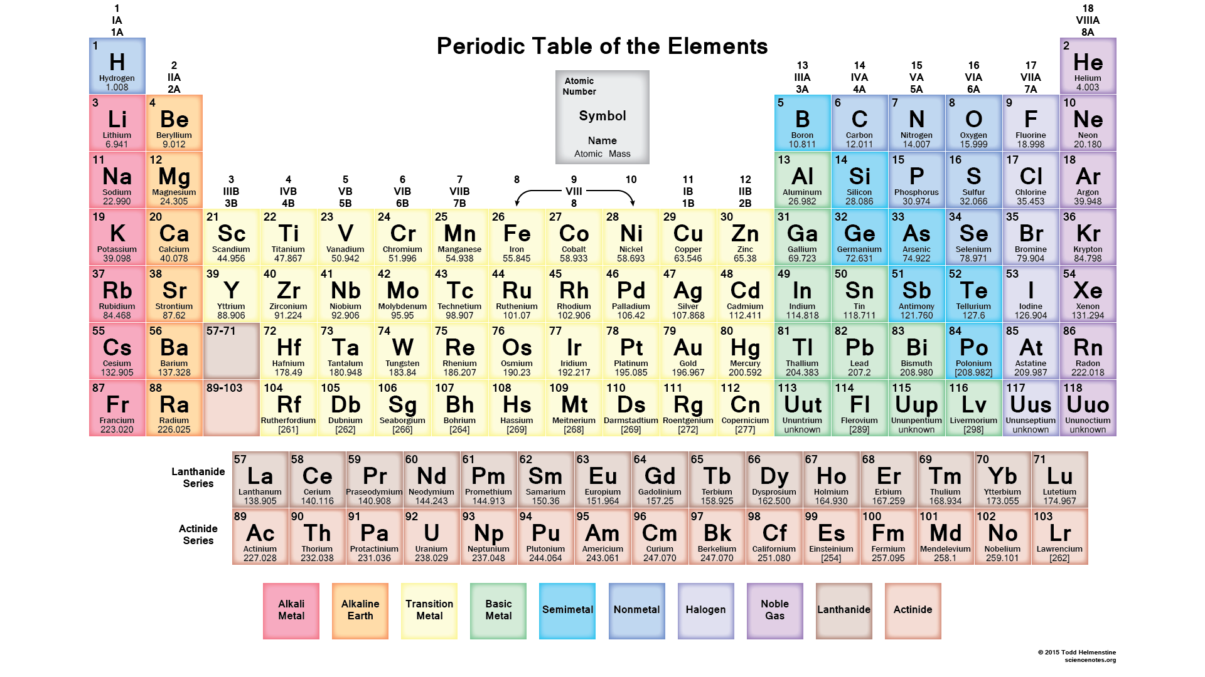

Reading a periodic table is easy if you know how to do it properly. First, you should understand what the alphabetical symbols mean. Each symbol is a one-two letter abbreviation derived from the element’s English or Latin name. Under this large symbol is the written out name of the element. On the top of a certain piece of the table, is a whole number. This whole number represents the atomic number. The atomic number is equal to the amount of protons in the nucleus of the element. This number is also equal to the number of electrons in the electron cloud. Next is the decimal number on the very bottom of the card of an element. This number is the atomic mass. The atomic mass is a weighted mass of all of the element’s isotopes.
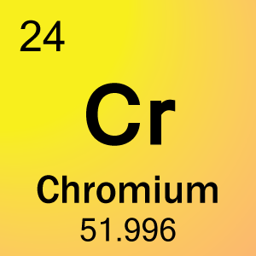
For example, take Chromium. As you can see, we have our two letters in the middle of the card. That is the abbreviation for Chromium, the word seen beneath the symbol. In the top left corner, we see the number twenty-four. This represents the element’s atomic number. Under the word “Chromium”, we see the number 51.996. This is the atomic mass of the element.
Periodic Table History
The Periodic Table was started in 1869 by a Russian chemist named Dmitri Mendeleev. The first thing he did was arrange the elements by atomic mass. He predicted the discovery of other elements, and left spaces open in his periodic table for them.
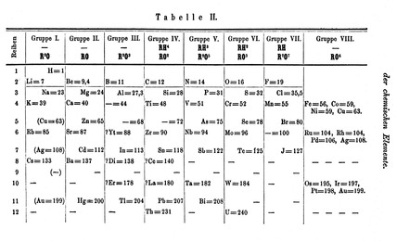
This is Mendeleev’s 1871 version of the Periodic Table.

There were other attempts that we not as successful. The earliest attempt to classify the elements was in 1789 by Antoine Lavoisier grouped the elements based on their properties into gases, nonmetals, metals and earths. Several other attempts were made to group the elements together in later years. In 1829, Johann Dobereiner recognized trends of the elements with chemically similar properties, such as lithium, sodium and potassium, and showed that the properties of the middle element could be predicted from the properties of the other two.

Through many years and many different versions of the Periodic Table scientists came up with our current one:

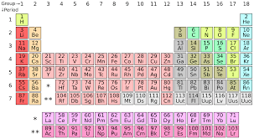

Final Test

- Who discovered the first element?
- What was the element he discovered?
- What is the definition of matter?
- Name 3 elements that granite is made up of.
- What are 3 parts of the element?
- Can you destroy or make an atom?
- What is a combinational element?
- What is the most common combinational element?
- What is a chemical property?
- What is an example of physical change?
11. What is matter?
12. What are the three types of matter?
13. How much of Earth’s atmosphere is made up of nitrogen?
14. How much of the human body is oxygen?
15. What are all salts made up of?
16. What is table salt called?
17. What is the top number on each element card?
18. What is the number on the bottom of each element card?
19. Who officially started the Periodic Table?
20. When was the earliest attempt to classify elements?

Final Test Answer Sheet

- Hennig Brand
- Phosphorus
- It is a physical substance.
- Iron, Magnesium, Titanium
- Protons, Electrons, Neutrons
- No you cannot.
- A combination of two or more elements to create a new substance.
- H2O
- A material’s property after a chemical reaction has occurred.
- Gas to Liquid.
- Anything that takes up space and has mass.
- Solid, Liquid, Gas.
- 70%
- 65%
- Solid and Chlorine
- Sodium Chloride
- The atomic number
- Atomic Mass
- Dmitri Mendeleev
- 1789

